PROJECT DOCUMENTATION
AI FIT TRACK: AI- BASED PERSONALIZED FITNESS SYSTEM

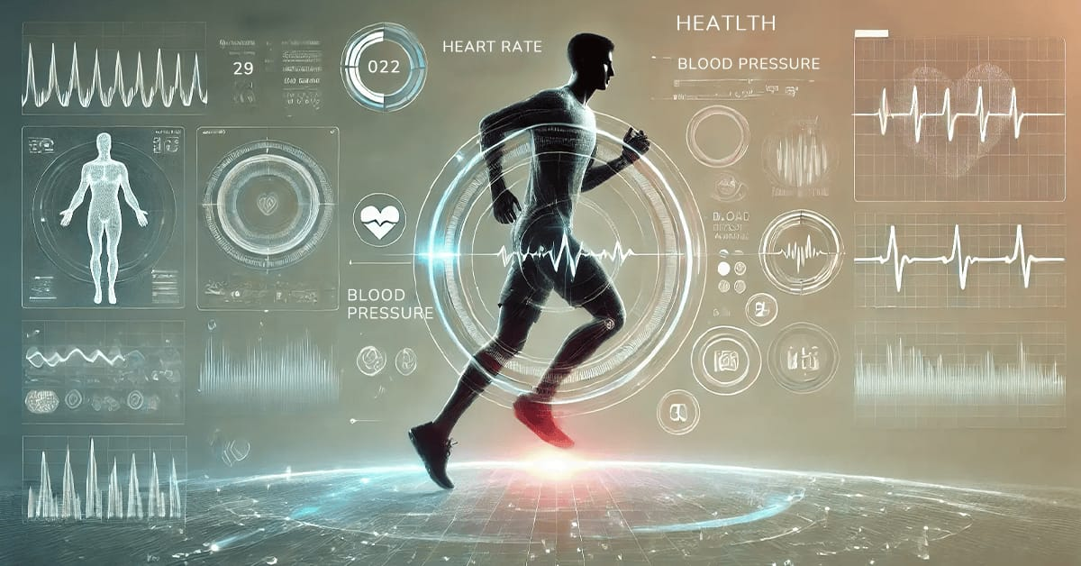

Team ID: NM2025TMID36561

Team Leader:
- Abinaya. A- 24csabinaya001@gmail.com
Team Members:
- Abirami. S- 24csabirami002@gmail.com
- Afrin. Z- 24csafrin003@gmail.com
- Akshaya. M- 24csakshaya004@gmail.com

PROJECT OVERVIEW:
FitTrack AI is an AI-powered fitness application developed using Node.js, Express.js, MongoDB, and Google Gemini AI. It helps users manage their workout activities, track fitness progress, and receive personalized workout recommendations. The system supports secure user authentication, workout management, workout searching, and AI-assisted fitness guidance through a simple and user-friendly platform.

MAIN OBJECTIVES:
- To provide personalized workout recommendations based on user fitness goals.
- To help users manage and track their workout activities.
- To provide AI-based fitness guidance and recommendations
- To help users search and access suitable workouts.
- To analyse workout statistics and fitness progress.
- To provide secure user authentication and data management.
- To create a simple and user-friendly fitness platform.

SCENARIO -BASED CASE STUDY:
BACKGROUND
Rahul is a fitness enthusiast who works out regularly and wants to maintain a healthy and active lifestyle. However, he finds it difficult to keep track of his workout activities, monitor his fitness progress, and select suitable exercises for his fitness goals.

PROBLEM:
Managing workout activities, tracking fitness progress, and finding suitable exercises can be difficult. Users may also lack personalized guidance based on their fitness goals.
SOLUTION:
FitTrack AI combines workout tracking with Gemini AI to provide personalized workout recommendations and easy-to-understand fitness insights.
OUTCOME:
The system helps users manage their workouts, monitor their fitness progress, and make better workout decisions while securely managing their personal fitness information.

SYSTEM SETUP &RESOURCE REQUIREMENTS:
SOFTWARE REQUIREMENTS:
- OS: Windows 10/11, macOS, or Linux.
- Node.js & npm: For backend development and package management.
- MongoDB & Mongoose: For storing and managing fitness and workout data.
- Gemini AI: For AI-based fitness recommendations and insights.
- Postman: For API testing.
- VS Code: For coding and project development.
HARDWARE REQUIREMENT:
- Processor: Intel Core i5 or equivalent AMD processor.
- RAM: Minimum 8 GB.
- Storage: 1GB Free Space
- Internet: Required for Gemini AI services and API communication.
EPIC 1: PROJECT REQUIREMENTS:
The FitTrack AI system is designed using a structured MVC architecture that separates application logic, data handling, and user requests. The Model handles user accounts, work out details, fitness information, and workout history using MongoDB and Mongoose for data management. The View provides a user-friendly interface for users to manage workouts, track fitness activities, and view their progress.
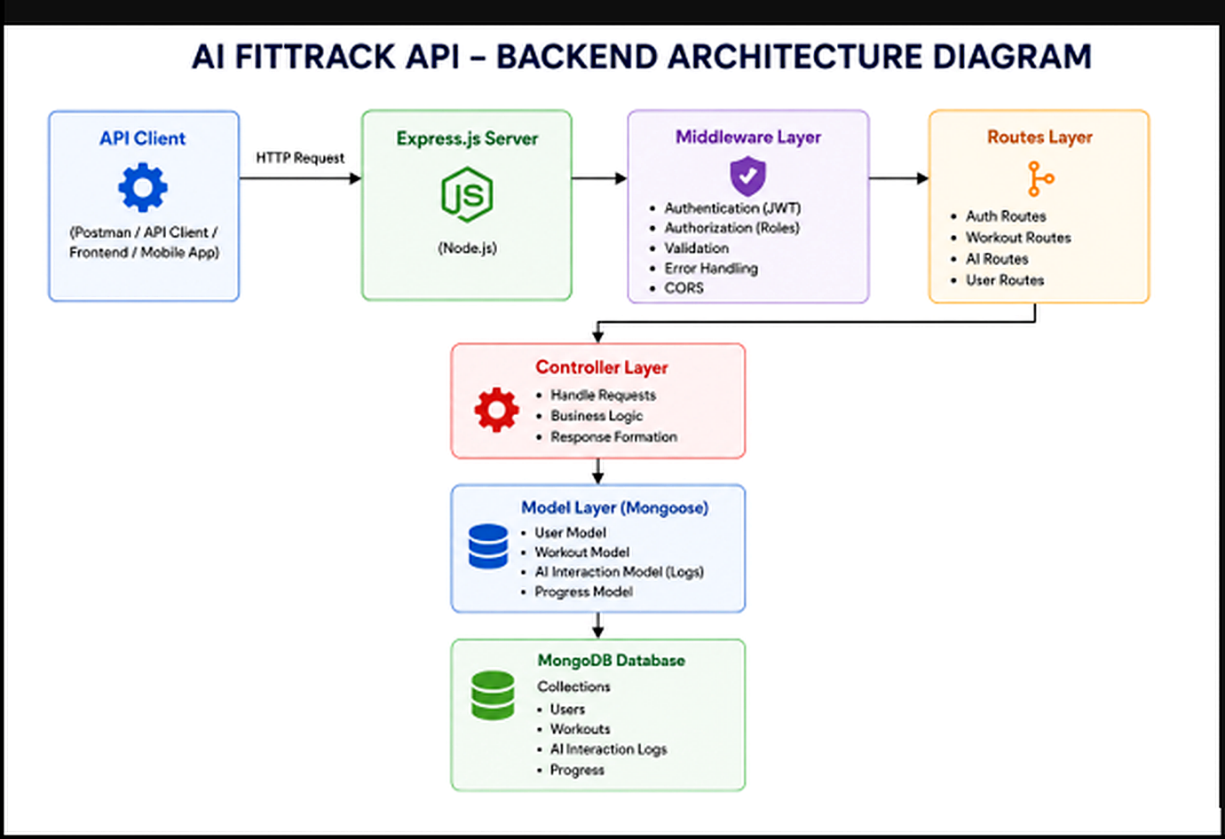

FIT TRACK AI- CORE ARCHITECTURE:

1. API Client:
The user sends requests through Postman, an API Client, Frontend, or Mobile Application. The request is sent to the Express.js server through HTTP.
2. Express.js Server:
The Express.js server, running on Node.js, receives and processes HTTP requests. It acts as the main server that connects the client with the different backend components.
3. Middleware Layer:
The Middleware Layer manages important request-processing functions such as JWT authentication, authorization, input validation, error handling, and CORS.
4. Routes Layer:
The Routes Layer defines the different API endpoints of the application. It contains Authentication Routes, Workout Routes, AI Routes, and User Routes and directs requests to the appropriate controller.
5. Controller Layer:
The Controller Layer handles incoming requests, business logic, and response formation. It processes the request received from the routes and communicates with the model layer when database operations are required.
6. Model Layer (Mongoose):
The Model Layer uses Mongoose to define and manage the application's data models, including the User Model, Workout Model, AI Interaction Model, and Progress Model.
7. MongoDB Database:
MongoDB stores the application's data in collections. It manages information such as users, workouts, AI interaction logs, and progress records.

ENTITY RELATIONSHIP (ER) DIAGRAM DESCRIPTION
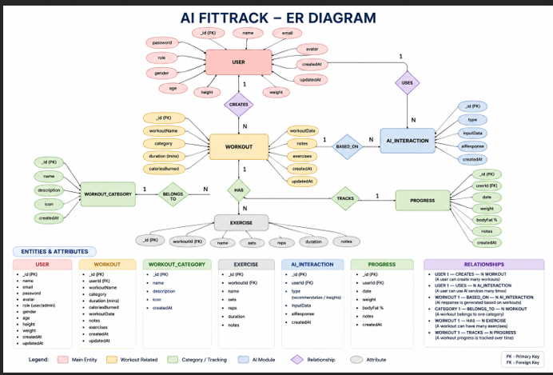
1.USER ENTITY:
The User entity stores authentication and profile information.
ATTRIBUTES:
- _id: Object Id: Primary Key (unique identifier for the user).
- Name: String: Username.
- Email: String: Unique Email Address
- Password: String: Encrypted password
- Created At: Date: Record Creation Time
- Updated At: Date: Last Updated Time
2.WORKOUT ENTITY:
The Workout entity stores workout-related information for each user.
ATTRIBUTES:
- _id: Object Id – Primary Key (Unique identifier for the workout entry)
- User Id: Object Id – Foreign Key
- Workout Type: String – Type of workout
- Duration: Number – Duration of the workout in minutes
- Calories Burned: Number – Estimated calories burned during the session
- Created At: Date – Record Creation Time
ROLES AND RESPONSIBILITIES:
The AI FitTrack backend supports one primary role.
AUTHENTICATED USER

Responsibilities
- Register an account
- Login securely.
- View profile information.
- Add workout records.
- View workout history.
- Search workouts.
- Update workouts.
- Delete workouts.
- Request AI workout recommendations.
- Request AI fitness insights.
USER FLOW:
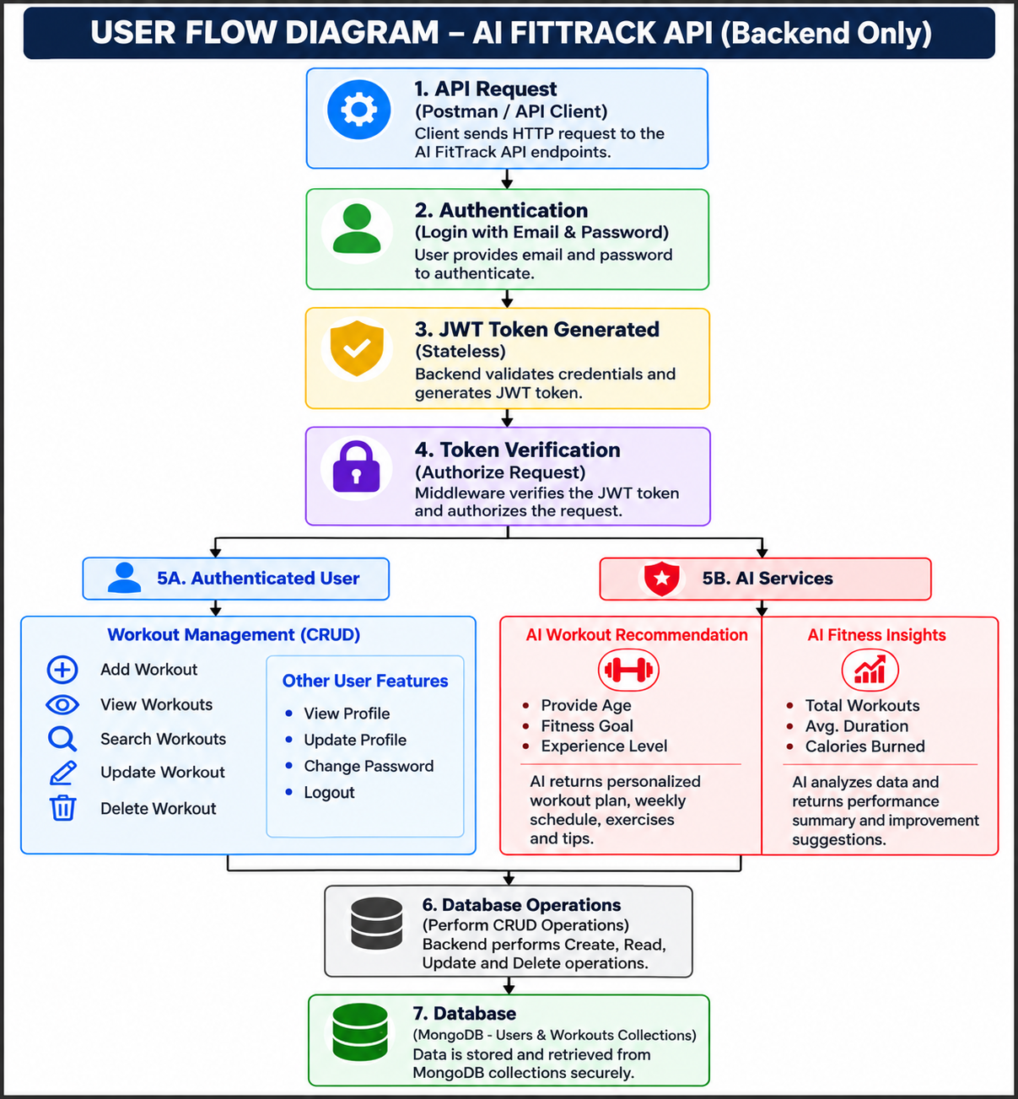
MVC ARCHITECTURE PATTERN
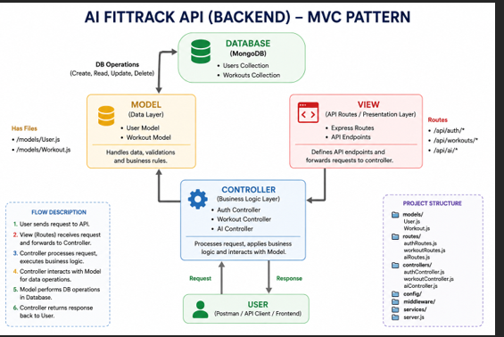

MODEL LAYER (DATA LAYER):
The Model Layer defines the structure of the application's data using Mongoose schemas. It communicates directly with MongoDB and performs database operations.
Responsibilities:
- Schema Definition
- Data Validation
- CRUD Operations
- Collection Mapping
VIEW LAYER (API INTERFACE):
AI FitTrack is a backend REST API, there are no traditional UI templates. The View Layer is represented by API consumers such as React applications, mobile applications, or Postman, which interact with the backend through HTTP requests and receive JSON responses.
Responsibilities:
- Send Requests
- Receive JSON Responses
- Display Data
- Handle Client-side Interaction

CONTROLLER LAYER (BUSSINESS LOGIC):
The Controller Layer acts as the intermediary between the View and Model. It processes incoming requests, validates input, invokes services and models, and sends structured JSON responses back to the client.
Responsibilities:
- Request Validation
- Business Logic Execution
- Database Interaction
- AI Service Invocation
- Response Generation
EPIC 2: PROJECT SETUP AND CONFIGURATION
The FitTrack AI project follows a well-structured backend architecture that separates business logic, routing, database operations, middleware, and AI services into individual modules. This modular design improves code readability, maintainability, and scalability while making the project easier to debug and extend.
The backend is developed using Node.js and Express.js, with MongoDB as the primary database and Google Gemini AI for intelligent fitness recommendations.

CREATING PROJECT FOLDER

STEP 1: Create the Project Folder
Create a folder for the Fit Track AI project
STEP 2: Open the project
Open the project folder in the Visual Studio Code
STEP 3: Create the Server Folder
Inside the project directory, create a folder named
Server
All backend source code will be maintained inside this folder.
STEP 4: Initialize Node Project
Open the terminal inside the server folder and execute:
npm init -y
This command generates the package.Json file containing project metadata and dependency information.
Step 5: Install Required Packages
Install the required backend dependencies such as Express.js, Mongoose, JWT, bcrypt, CORS, and Google Gemini AI.

EPIC 3: BACKEND DEVELOPMENT:
Backend development focuses on implementing REST APIs that allow authenticated users to manage workouts and interact with Google Gemini AI.
The project is divided into multiple modules that collectively perform authentication, workout management, AI integration, and database operations.

Major modules include:
- Server Configuration
- Database Configuration
- Authentication
- Workout Management
- AI Recommendation
- Middleware
- Error Handling
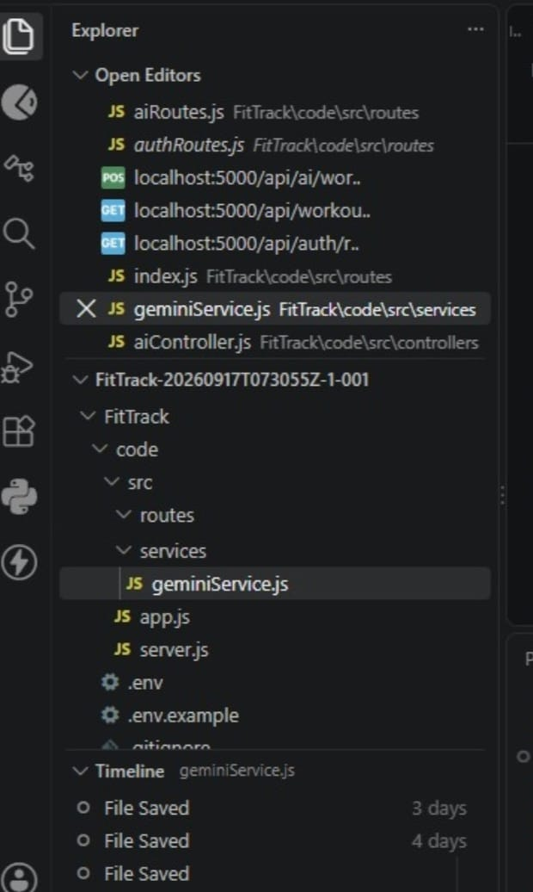

EPIC 4: DATABASE CONFIGURATION
The FitTrack AI uses MongoDB as its primary NoSQL database for storing user credentials and workout information. Mongoose serves as the Object Data Modeling (ODM) library, enabling seamless interaction between the application and the MongoDB database. Mongoose provides schema validation, middleware support, data relationships, and simplified CRUD operations.
The database layer is responsible for maintaining data integrity, validating incoming requests, and ensuring secure storage of user information.

MONGODB CONFIGURATION:
MongoDB stores application data in collections rather than traditional relational database tables. The FitTrack AI maintains separate collections for users and workouts.

Database Collections:
- Users Collection
- Workouts Collection
Each collection stores JSON-like documents (BSON format), allowing flexible schema design while maintaining efficient data retrieval.
INSTALLING MONGOOSE:
Install Mongoose using npm
Npm install mongoose
Mongoose acts as the bridge between the Node.js application and MongoDB by providing schema definitions, validation, and database methods.
MONGODB CONNECTION
The database connection is configured inside the config/db.js file. This module establishes a connection to the MongoDB server when the application starts.
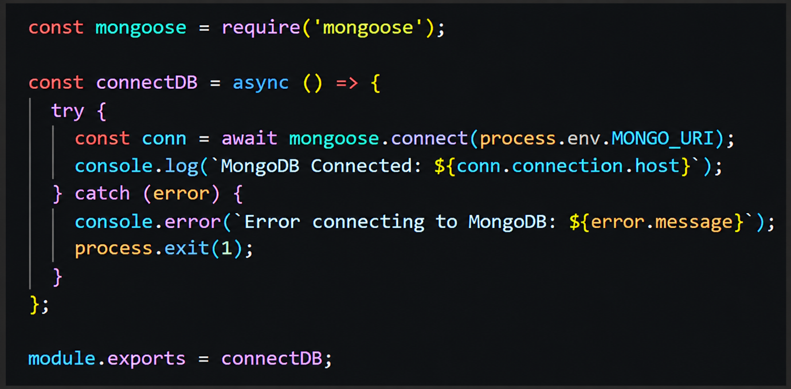
Advantages:
- Centralized database connection management
- Reusable and organized database configuration
- Reliable connection handling
- Simplified error management

EPIC 5: PROJECT EXECUTION
API testing ensures that every endpoint functions correctly and returns the expected response. The FitTrack AI is tested using Postman, allowing developers to verify request handling, authentication, database operations, and AI integration.

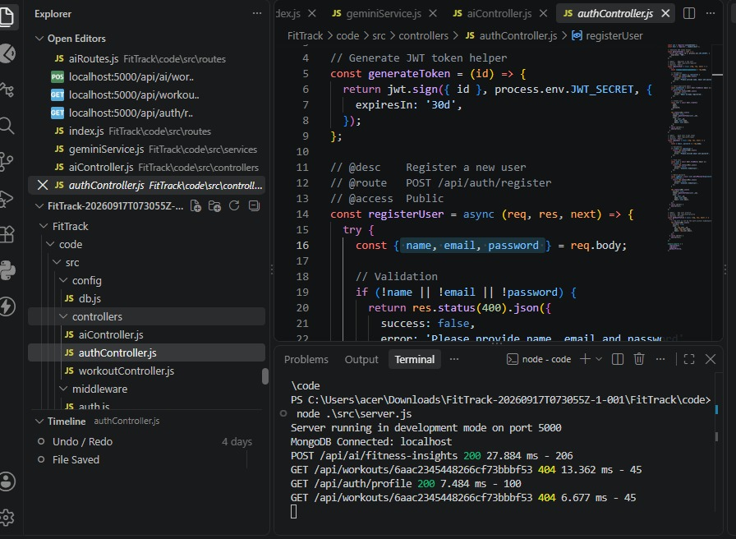

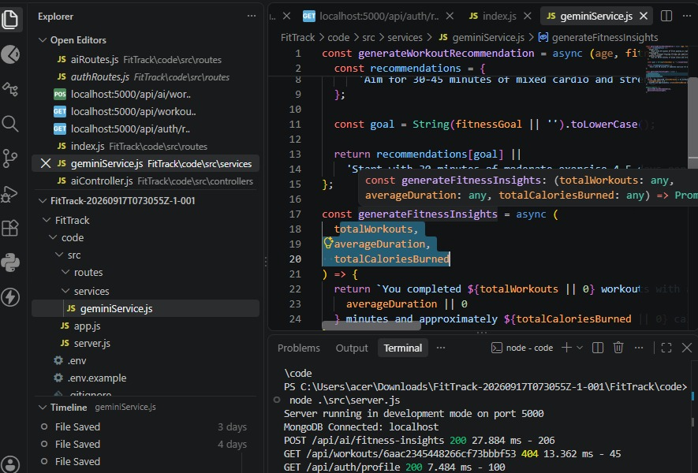

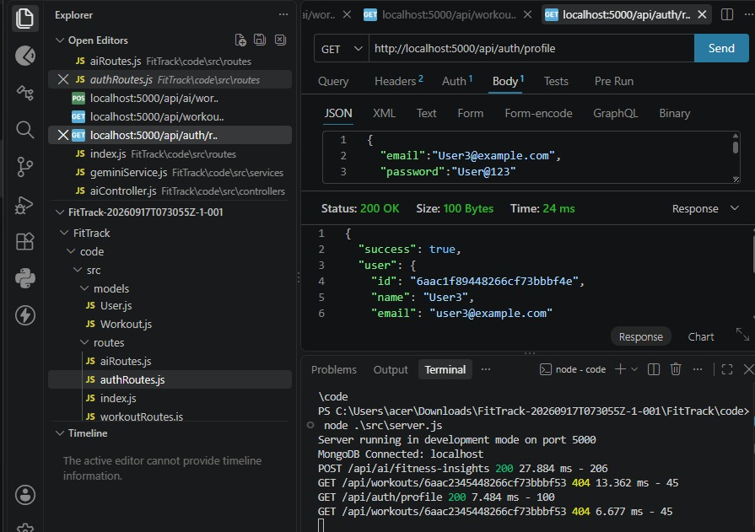
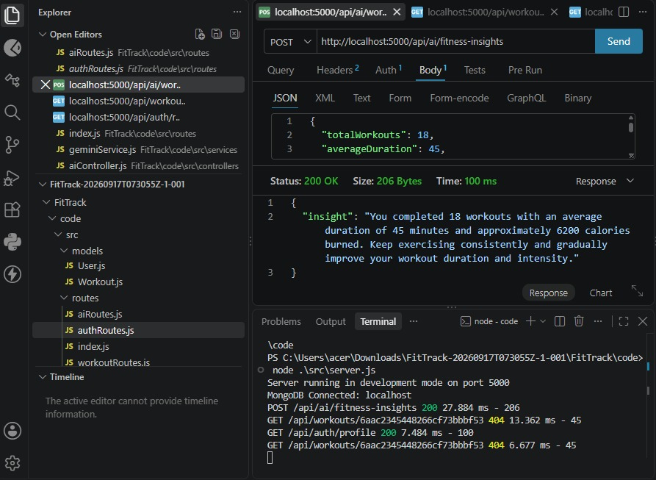

OUTPUT:

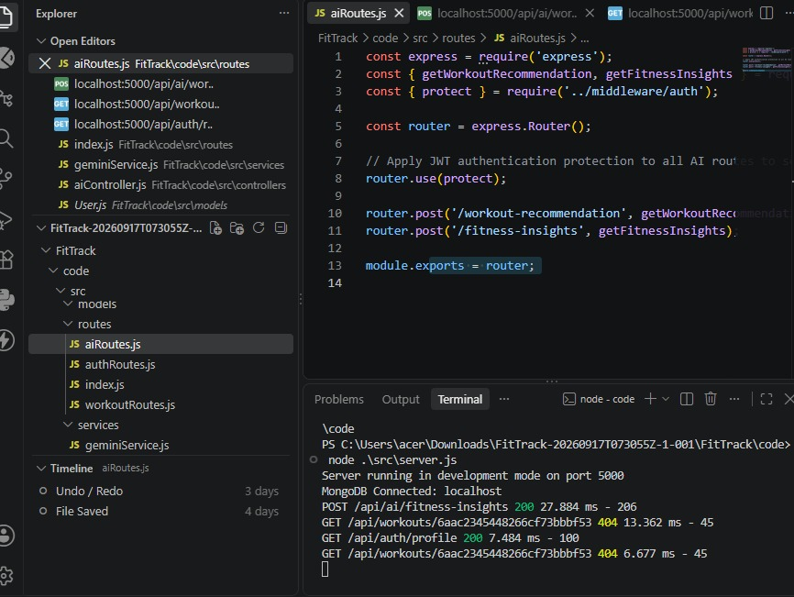

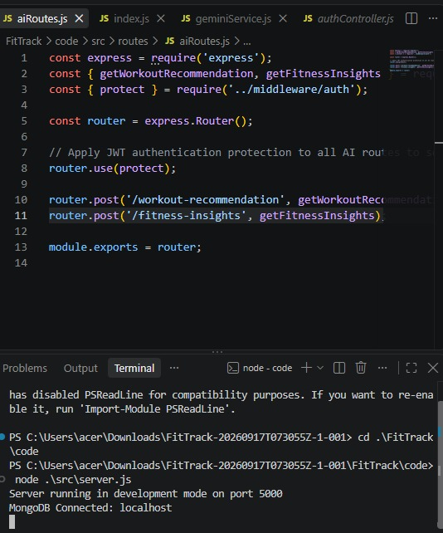

CONCLUSION:
The FitTrack AI project provides a smart platform for workout tracking and personalized fitness management. AI-driven features help users receive fitness insights and track their progress effectively. The system also provides scope for future enhancements such as wearable device integration and predictive analytics.

ATTACHMENTS:

Demo Video Link: https://drive.google.com/file/d/1xcJuQsCuvDZgo9Sf38wLL-UqAtg4y7FI/view?usp=drivesdk

API Testing Video: https://drive.google.com/file/d/1TCXG48a-78ryxF3gipdRMwRBwuhAgPaa/view?usp=drive_link

CodeDrive: https://drive.google.com/drive/folders/1hwmKxkHQkUI62JR1svI3xCQ2ShZ6Lj9y

